**R Code for Examples in the book**

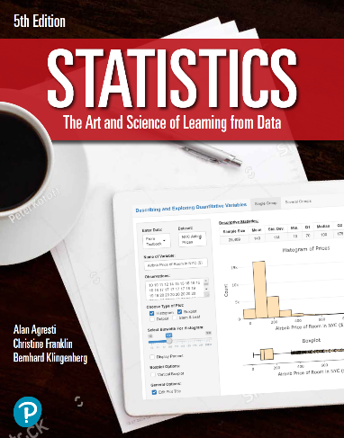

***“Statistics: The Art and Science of Learning from Data”***

**by Agresti, Franklin and Klingenberg, 5th edition**

**Chapter 15**

**Example 2: Tanning Studio vs. Lotion – P-Value for Wilcoxon Test**

## Reading in data

lotion <- c(2, 4, 5)  
tan <- c(1, 3)

## To perform a Wilcoxon Test, you can use the wilcox.text() function.

wilcox.test(lotion, tan, conf.int = TRUE)

##   
## Wilcoxon rank sum exact test  
##   
## data: lotion and tan  
## W = 5, p-value = 0.4  
## alternative hypothesis: true location shift is not equal to 0  
## 80 percent confidence interval:  
## -1 4  
## sample estimates:  
## difference in location   
## 1.5

## Note that R subtracts n1 * (n1 + 1) / 2 from the test statistic where n1 is the sample size in group 1; other statistical softwares may not necessarily do the same